Consider the problem of building a wall out of 2×1 and 3×1 bricks (horizontal×vertical dimensions) such that, for extra strength, the gaps between horizontally-adjacent bricks never line up in consecutive layers, i.e. never form a "running crack".

For example, the following 9×3 wall is not acceptable due to the running crack shown in red:

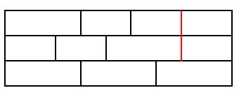

There are eight ways of forming a crack-free 9×3 wall, written W(9,3) = 8.

Calculate W(32,10).

Your program should be written in C, C++, C#, Java, Python, or Ruby. The program should produce one line of output consisting of the numerical answer to the problem. You should zip up your source code for your program and return it before your interview.

Note that the program you produce is just as important as having the correct answer. The purpose of this exercise is to provide a starting point from which we can discuss your programming skills during the interview.